

**JOMO KENYATTA UNIVERSITY OF AGRICULTURE**

**AND TECHNOLOGY**

**DEPARTMENT OF ELECTRICAL AND ELECTRONIC ENGINEERING**

**BSc Electronic and Computer Engineering**

**PROJECT PROPOSAL ABSTRACT**

**PROJECT TITLE:**

**SOLAR POWERED WATER FILTRATION AND PURIFICATION SYSTEM**

**Submitted by:**

**CHARLES KARIRA - ENE212-0267/2016**

**JOSEPHINE TARIYA - ENE212-0073/2016**

**PROJECT SUPERVISOR**

**PROF. NJOROGE**

*A Final Year Project Proposal submitted to the Department of Electrical and*

*Electronic Engineering in partial fulfillment of the requirements for the Award of a*

*Bachelor of Science Degree in Electronic Engineering.*

**JULY 2021**

**DECLARATION**

This project proposal is my original work, except where due acknowledgement is made in the text, and to the best of my knowledge has not been previously submitted to Jomo Kenyatta University of Agriculture and Technology or any other institution for the award of a degree or diploma.

**ACKNOWLEDGEMENT**

Part of the project was used in the Energy for Efficiency for Access Design Challenge 2021

SIGNATURE………………………………………… DATE ………………………………

SIGNATURE………………………………………… DATE ………………………………

**NAME: REG No.:**

JOSEPHINE TARIYA ENE212-0073/2016

CHARLES KARIRA ENE212-0267/2016

**TITLE OF PROJECT:**

**SOLAR POWERED WATER FILTRATION AND PURIFICATION SYSTEM**

**SUPERVISOR CONFIRMATION:**

This project proposal has been submitted to the Department of Electrical and Electronic Engineering, Jomo Kenyatta University of Agriculture and Technology, with my approval as the University supervisor:

**NAME OF SUPERVISOR………**S, N. NJOROGE**………………**

**SIGNATURE: ……………………………… DATE: ……………………………………….**

ABSTRACT

Access to safe drinking water and improved health is a human right. In this proposal we shall be designing a water purifier which works on solar energy. The main principle behind our project is ultra-violet water purification. The solar radiations are collected by the solar panel. The energy is then stored in a battery. The battery is then connected to a voltage regulator to control voltage to the ultra violet (UV) LED. The purification unit consists of water pump, ultrafiltration filter membrane and ultra-violet (UV-C) chamber. The pump creates a necessary pressure required for ultra-filtration. The microcontroller is used to control the operation of the pump and ultra-violet LED. The design of UV-C chamber has been covered in this proposal. The system comprises of main treatment stage and post-treatment stage. In the main treatment, the ultrafilter filters out unseen materials, biological contaminants and disease-causing microorganism while in post-treatment stage the UV-C LEDs inactivates them using electromagnetic radiation of wavelengths between 200-280 nm. The whole system is powered using solar energy which is a clean, cheap and renewable source with zero emissions.

**TABLE OF CONTENTS**

ABSTRACT ii

1. INTRODUCTION. 1

1.2 Problem statement 3

1.3 Project justification. 3

1.4 Objectives 4

2. LITERATURE REVIEW 6

2.1 Existing methods of water purification 6

2.1.1 Boiling 6

2.1.2 chemical methods 6

2.1.3 solar water disinfection (SODIS) 7

2.2 Filtration technology backgrounds 8

2.2.1 Ultrafiltration 8

2.2.2 Nanofiltration 10

2.2.3 Microfiltration 10

2.2.4 Reverse osmosis RO 11

2.3 UV purification 12

2.3.1 UV disinfection 12

2.3.2 Germicidal effect 13

2.3.3 LED Advantages 15

3. METHODOLOGY 17

3.1 Design specifications of the proposed water purifier 17

3.2 Components of the Proposed Solar water purifier 17

3.3 Design of UV-C chamber 19

3.4 Control Mechanism 20

3.4.1 Block diagram 20

3.5 Microcontroller 22

3.6 Water filtration and purification process 24

3.6.1 System layout design 25

3.7 Energy consumption and Panel Sizing 25

3.7.1 Energy consumption 27

4. EXPECTED RESULTS 28

BUDGET 30

REFERENCES 32

**LIST OF FIGURES**

Figure 1-2.1.3 WADI from Engineering for Change Solutions Library 7

Figure 2-2.2.1 ultrafiltration 10

Figure 3-2.2.2 Nano filtration 10

Figure 4-2.2.3 microfiltration 11

Figure 5-2.2.4 reverse osmosis 12

Figure 6-2.3.1 UV-C in spectrum of Electromagnetic radiation 13

Figure 7-2.3.2 Germicidal effectiveness of UV lamps 14

Figure 8-2.3.3 the circuit (top) and band diagram (bottom) on how an LED works 15

Figure 9-3.2.1 Ultrafiltration filter 18

Figure 10-3.2.3 UV-C LED 18

Figure 11-3.4.1 (a) Block diagram 21

Figure 12-3.4.1 (b) Flow Chart 22

Figure 13-3.5 SIM800L Microcontroller 23

Figure 14-3.6 Process Flow diagram 24

Figure 15- 3.6.1 Design layout 25

**LIST OF TABLES**

Table 1-2.2 Filtration technology comparisons 8

Table 2-2.3.2 UV Dosage requirements for microorganism's inactivation 14

Table 3-3.6 Water Treatment stages 24

**List of Abbreviations and Acronyms**

LED Light Emitting Diode

UV Ultra-Violet

RO Reverse Osmosis

**CHAPTER ONE**

1. INTRODUCTION.
   1. Background Information

Waterborne diseases in developing countries cause thousands of deaths and even more cases of diseases mostly affecting children. In the rural areas of developing countries boiling is the most often used method for purifying water for food preparation and drinking. However, boiling is relatively expensive, consumes substantial amount of fossil energy and the associated wood gathering causes depletion of forest cover. Among the available alternatives solar water purification is the most promising approaches for energy efficient, cost effective [1], robust and reliable solution to these problems.

There is a great and urgent need to supply environmentally friendly technology for the provision of drinking water in rural areas. Water is one of the most essential natural resources gifted to humankind. But the rapid development of the society, population growth and numerous human activities have sped up the contamination and deterioration of existing sources. Pure clean drinking water is necessary for survival. Water supply is either ground water or surface water sources. The water from each of these sources contains sediments and other solids.

Biological contaminants are of different types including different types of bacteria such as Escherichia coli [6] and Vibrio cholerae. The degree to which the biological contaminants may pose threats to environmental and human health is dependent on the type and concentration. There are many health risks associated with exposure to biological contaminants in water including diseases such as typhoid and cholera.

The search for clean water is a human endeavor as old as thirst itself. Many people in rural areas do not have access to clean water. The aim of our project is to filter and purify water using solar power in rural areas. The main theme is about using a customized water filtration and purification tower that incorporates a small DC motor and a UV Purification system. Ultraviolet purification is the most effective method for disinfecting bacteria from water. UV systems destroy 99.99% of harmful microorganisms without adding chemicals or changing the waters taste and odor.

Ultraviolet (UV) radiation treatment is an effective method for the disinfection of bacterial and viral contaminants present in water as it serves as an alternative technology to chemical disinfection techniques. It has the benefit of fast treatment, minimal hazards associated with chemical handling and disposal and reduced costs. The wavelength responsible for the treatment of water is generally shorter at around 280 nm which places it in the UV-C region (200-280 nm). UVC radiation absorption causes the inactivation of microbe contaminants in water by damaging their DNA [5]. UV based systems do not remove objects from the water but rather they kill organic material that causes illness.

UVC light-emitting diodes [3] are gaining popularity as an alternative technology which can overcome the limitations of conventional mercury-containing UV lamps. For instance, their small size makes them easy to incorporate into a sterilization system and since they don’t contain mercury thus alleviating risks of human and environmental toxicity.

Ultrafiltration UF is a pressure-driven membrane separation mechanism that removes suspended particulate matter and some dissolved compounds with high molecular weight from contaminated water. UF is highly efficient in filtering out microorganisms from water making the technology ideal for water purification systems. Moreover, the UF treatment systems are also useful when applied as pre-treatment units before reverse osmosis and UV treatment systems as disinfection requirements are greatly reduced due to the reduction in suspended solids.

As for power the distributed nature of households in the rural communities without access to electricity makes the use of photovoltaic technology (PV) an appropriate option to power the water purifying systems. Solar is highly reliable and has a lifetime of more than 25 years and the resource they depend on(sunshine) is sufficiently available almost everywhere in the world making it a universal choice.

Solar water disinfection (SODIS) involves exposing water-filled plastic polyethylene terephthalate (PET) bottles to sunlight for several hours [27]. Exposure times vary depending on weather and climate from a minimum of six hours to two days during fully overcast conditions. The World Health Organization as a viable method for household water treatment and safe storage recommends it. Over two million people in developing countries use this method for their daily drinking water. However, it has many setbacks compared to our proposed solution. Some of the setbacks are dependency on high solar radiations, continuous cleansing of plastic bottles, low flow rates and inability to treat large amounts of water at a time.

The principle behind our project is UV purification and ultrafiltration. This report looks at the efficient combination of solar to power UV water purification systems and the advantages of UV LEDs over mercury lamps as sources of UV radiation. We are using solar energy which is a renewable source, abundant and cheap. We plan on using a microcontroller together with GSM module which monitors the treated water. A solar panel is used as source of energy that charges the battery. The battery will then power the microcontroller, GSM module, UV led, flow meter and LCD display. An emphasis is placed on this solution that is effective, reliable, safe and sustainable for use in rural off-grid areas mainly in Kenya.

* 1. Problem statement

Approximately 9.4 million people in Kenya drink directly from contaminated water sources [29]. Approximately 19,500 Kenyans, including 17,100 children under five, die each year from water borne diseases [29]. These figures can be reduced with access to clean water and sanitation.

Access to safe water and sanitation contributes to improved health and helps prevent spread of infectious diseases. Many people do not have access to electricity or access to electric appliances that can operate off grid. Majority of the water purification systems do not operate off grid and therefore the need to provide an off-grid solution to guarantee access to clean water.

Improvements in point-of-use (POU) drinking water disinfection technologies for remote and regional communities are urgently needed and as such a decentralized system such point of use solar UV-C disinfection is a viable alternative which could be handy when incorporated with rainwater harvesting technologies.

* 1. **Project justification.**

The project is significant because it will assist to prevent the spread of water-borne diseases by providing communities in remote areas with safe drinking water. Water that has been disinfected with UV-C will be safe to drink. It is suited in places not linked to the grid by using solar energy through solar panels, and it is both inexpensive and easy.

* 1. **Objectives**

The objectives of this project are to come up with a water filtration and purification system that is powered by solar, portable and readily available to off-grid communities in rural areas who do not have access to clean drinking water.

* + 1. Main objectives

To design and implement a solar based water filtration and purification system.

* + 1. Specific objectives

1. To design a solar powered water filtration unit
2. To construct a solar powered water filtration unit
3. To design an ultra-violet purification system for water disinfection
4. To implement an ultra-violet purification system for water disinfection and purification
5. To develop a prototype for water filtration and purification
   1. Division of Roles

CHARLES KARIRA ENE212-0267/2016

1. Literature Review – UV Disinfection
2. Design calculations of UV Chamber
3. Pump design, flow rates and integration

JOSEPHINE TARIYA ENE212-0073/2016

1. Literature Review – Ultrafiltration
2. Microcontroller research and implementation
3. Fabrication of water filter unit

**CHAPTER TWO**

1. LITERATURE REVIEW

The development of efficient water treatment technologies especially inactivation of pathogenic microorganisms in drinking water is of great importance for human health and well-being. Also, power usage is crucial for such purification systems and with application of solar energy this increases efficiency and provides access to users not connected to the grid. Several methods can be used to purify and clean drinking water. Major focus is given to ultrafiltration and UV disinfection which will be used as the main treatment process in our project.

* 1. Existing methods of water purification
     1. Boiling

Boiling is the most used point of use water treatment approach in most homes. Most people use firewood for boiling drinking water because this option kills majority of the microorganisms, it’s simple and very widely accepted method. However, this method odes not remove more dangerous contaminants. Also, use of biomass fuels (charcoal and firewood) is not sustainable as it is very dependent on natural resources leading to degradation of the environment.

* + 1. chemical methods

Different chemical methods are being used to purify drinking water. They include chlorine tablets and fluoride removal. These methods involve addition of chlorine in municipal water to kill pathogens effectively. However, this produces byproducts that cause some health concerns.

Chlorine

Chlorine is the most widely used primary disinfectant and is also often used to provide residual disinfection in the distribution system. Monitoring the level of chlorine in drinking water entering a distribution system is normally considered to be a high priority (if it is possible), because the monitoring is used as an indicator that disinfection has taken place. Residual concentrations of chlorine of about 0.6 mg/l or more may cause problems of acceptability for some consumers on the basis of taste. Monitoring free chlorine at different points in the distribution system is sometimes used to check that there is not an excessive chlorine demand in distribution that may indicate other problems in the system, such as ingress of contamination.

* + 1. solar water disinfection (SODIS)

This is a simple technology that relies on the use of sun’s energy only and photo destruction to inactivate disease causing microorganisms in water making it safe for drinking. This is possible with oxidative effect of radials formed by UV radiation for 4-6 hours on a sunny day. In solar disinfection pathogens are killed by the combined action of UV radiation and heat. This method is cheap, simple and uses renewable energy. However, it has the disadvantage of being highly dependent on solar radiation and contamination of plastic bottles and inability to treat large amounts of water. Such concerns include health risks associated with plasticizers and other carcinogenic compounds which may leach from the bottles into the water.

WADI is a monitoring device developed to trace the progress of solar water disinfection in a PET-bottle by detecting and calculating the UV-A rays of the sun, indicated by a status bar and smiley face. It measures the UV-A radiation of sun and indicates the point of time at which at least 3log10 reduction of bacteria has taken place. The visualization of the progress of the solar disinfection process eliminates user uncertainty but it’s still limited by dependence on solar radiation.

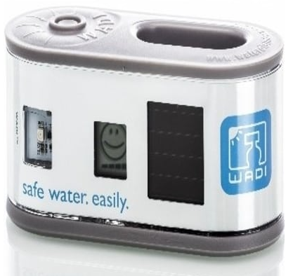

Figure 1-2.1.3 WADI from Engineering for Change Solutions Library

* 1. Filtration technology backgrounds

Membrane filtration is a technique used to separate particles from a liquid. A membrane is a thin layer of semi-permeable material that separates substances when a driving force is applied across the membrane. Membrane processes are used for removal of bacteria, microorganisms and particles. The membrane processes include ultra-filtration (UF), Nano-filtration (NF), and reverse osmosis (RO).

Table 1-2.2 Filtration technology comparisons

|  |  |  |  |  |
| --- | --- | --- | --- | --- |
|  | Microfiltration | Ultrafiltration | Nanofiltration | Reverse osmosis |
| Size of particle | >0.1 um | 0.1- 0.01 um | 0.01-0.001um | <0.001um |
| Type of particle | Suspended particles | Macro molecules, bacteria | Micro molecular organic compounds | ions |

* + 1. Ultrafiltration

Ultrafiltration is a separation process using membranes with pore sizes in the range of 0.1 to 0.001 micron. It removes high molecular-weight substances, colloidal materials, and organic and inorganic polymeric molecules. Low applied pressure is sufficient to achieve high flux rates for an ultrafiltration membrane. Flux of a membrane is defined as the amount of permeate produced per unit area of membrane surface per unit time. Generally, flux is expressed as gallons per square foot per day (GFD) or as cubic meters per square meters per day. Ultrafiltration membranes can have extremely high fluxes of between 50 and 200 GFD at an operating pressure of about 50 psig. Ultrafiltration is a cross-flow separation process. Here liquid stream to be treated (feed) flows tangentially along the membrane surface, thereby producing two streams. The stream of liquid that comes through the membrane is called permeate. The other liquid stream is called concentrate and gets progressively concentrated in those species removed by the membrane. In cross-flow separation, therefore, the membrane acts as a barrier to these species.

Conventional filters such as media filters or cartridge filters, on the other hand, only remove suspended solids by trapping these in the pores of the filter-media. These filters therefore act as depositories of suspended solids and have to be cleaned or replaced frequently. Conventional filters are used upstream from the membrane system to remove relatively large suspended solids and to let the membrane do the job of removing fine particles and dissolved solids. In ultrafiltration, for many applications, no pre-filters are used.

Ultrafiltration removes bacteria, protozoa and some viruses from the water. Nano-filtration removes these microbes, as well as most natural organic matter and some natural minerals, especially divalent ions, which cause hard water. Nano-filtration, however, does not remove dissolved compounds. Reverse osmosis removes turbidity, including microbes and virtually all dissolved substances. However, while reverse osmosis removes many harmful minerals, such as salt and lead, it also removes some healthy minerals, such as calcium and magnesium. This is why water that is treated by reverse osmosis benefits by going through a magnesium and calcium mineral bed. This adds calcium and magnesium to the water, while also increasing the pH and decreasing the corrosive potential of the water. Corrosive water may leach lead and copper from distribution systems and household water pipes [15].

Ultra-filtration has the following advantages the system operates at a low pressure, removes bacteria and viruses, keeps essential minerals in water, installs quickly and easily, does not generate waste water. An ultrafiltration system is eco-friendly [16]. Ultrafiltration has a 90-95% recovery rate and can be used to treat wastewater for reuse. Using a home ultrafiltration water system benefits the environment by reducing the amount of plastic water bottles discarded in landfills.

Some of the applications of ultrafiltration are in industries such as chemical and pharmaceutical manufacturing, food and beverage processing, and wastewater treatment, employ ultrafiltration in order to recycle flow or add value to later products. Blood dialysis also utilizes ultrafiltration.

The main disadvantage of ultrafiltration is the water from this procedure is not advisable for drinking by either human beings or animals. The reason for this is that the process does not separate soluble and therefore this soluble could be harmful to our health. One chemical that is very soluble in water is pesticides. Hence the need for purifying it.

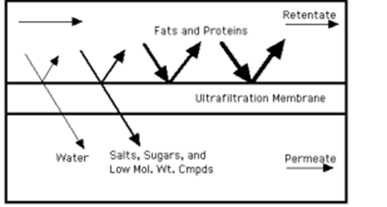

Figure 2-2.2.1 ultrafiltration

* + 1. Nanofiltration

Nano-filtration has a pore size range of 0.001-0.01um. Smaller than that used in microfiltration and ultrafiltration, but just larger than that in reverse osmosis. NF membranes can filter particles up to and including some salts, synthetic dies, and sugars, however, it is unable to remove most aqueous salts and metallic ions, as such; NF is generally confined to specialist uses. One of the main advantages of Nano-filtration as a method of softening water is that during the process of retaining calcium and magnesium ions while passing smaller hydrated monovalent ions, filtration is performed without adding extra sodium ions, as used in ion exchangers [17]. A main disadvantage associated with nanotechnology, as with all membrane filter technology, is the cost and maintenance of the membranes used [18].

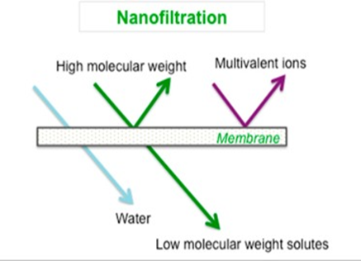

Figure 3-2.2.2 Nano filtration

* + 1. Microfiltration

The pore size on micro-filtration membranes ranges from 0.1 – 5 ums, and has the largest pore size of the four main membrane types. Its pores are large enough to filter out such things as bacteria, blood cells, flour, talc and many other kinds of fine dust in solution. Because its pores are relatively large compared to other membranes, it can be operated under low pressures and therefore low energy. The main advantage is that the process requires little pressure. The main disadvantage is that there is insufficient quality of the treated water [19].

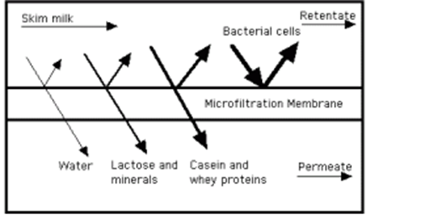

Figure 4-2.2.3 microfiltration

* + 1. Reverse osmosis RO

RO has a pore size range of 0.0001 – 0.001. It is by far the finest separation material available to the industry. This purification process removes particles 500,000 times smaller than a diameter of a single strand of a human hair. RO is successfully used for desalination and purification of water (or liquids) as it rejects everything but water molecules, with pore sizes approaching the radius of some atoms in many cases. This pore size means it is the only membrane that can reliably filter out salt and metallic ions from water. The small pore size of RO membranes means that a significant amount of osmotic pressure is required to force purification. Flow rates on RO membranes (36 GPD, 50 GPD, 75 GPD etc.) are limited to certain gallons per day rating. Some systems with high volume per day require pumps or flow restrictors to control volume, water pressure and flow rate within the system for maximum effectiveness [20]. The main advantage of RO is that it is a very effective way of water softening. In fact, it performs two functions, which are; water softening and water purification. It does not allow any particles except the water particles. The main disadvantage of RO is that lot of energy is required for the entire process and the water becomes acidic because it has been deionized of all its mineral content. It is not advisable drinking water from the process because naturally, the water must possess some minerals, which help in the functioning of the body. Hence, the water should be passed again through mineral beds of calcium and magnesium [21].

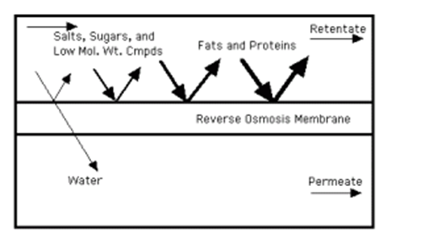

Figure 5-2.2.4 reverse osmosis

* 1. UV purification
     1. UV disinfection

Ultraviolet (UV) radiation, an electromagnetic radiation with a wavelength from 100nm to 400nm can effectively inactivate various microorganism in water and is increasingly being applied for water disinfection [7].

The effect of UV radiation largely depends on wavelength due to the different energy levels of photons. Thus, the electromagnetic spectrum of UV radiation can be subdivided into different ranges: UVA (315-400) nm, UVB (280-315) nm and UVC (200-280) nm. Although there is UVA radiation in natural sunlight it is inefficient and impractical for disinfection due to its poor absorption by cells of the micro-organisms. In practice UV disinfection mostly relies on the artificial UV sources emitting UVC or UVB radiation. The shortest wavelength of UV radiation (UV-C) poses the maximum risk to disease causing microorganisms. This is considered the germicidal UV wavelength range.

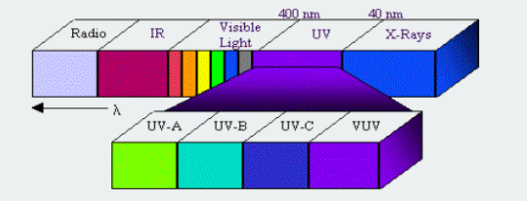

Figure 6-2.3.1 UV-C in spectrum of Electromagnetic radiation

The main UV sources for current UV disinfection systems are low or medium pressure mercury lamps [8]. Low pressure mercury lamps emit nearly monochromatic UV radiation with the peak wavelength at 254nm which is close to DNA absorption peak at around 260nm [13]. The UV radiation from the mercury lamps is strongly absorbed by the DNA of microorganisms leading to direct DNA damage by making them unable to reproduce.

Medium pressure mercury lamps MP emit a polychromatic spectrum with various wavelengths from UVC to UVA and visible light and have a much higher output than their low-pressure counterparts. Therefore, they disinfect water faster and have a greater penetration capability as compared to LP lamps.

All though these lamps are widely used for treatment there are still many issues with them. These lamps are very fragile and since they contain toxic mercury which is hazardous when improperly disposed [8]. UV lamps use a considerable amount of energy to operate with plug efficiency at around 15-35 % and have short lifetime of about 10,000 hours [9] [10].

* + 1. Germicidal effect

UV-C radiation is considered germicidal and is gotten from mercury lamps and UV LEDs. UV-C effectively kills airborne pathogens, surface and water living bacteria, viruses and other cysts forms. Low doses of radiation may not produce any adverse effects on cells. The intensity of UV radiation is measured in the units of millijoules per square centimeters . For effective disinfection high intensity of radiation and longer exposure times is necessary.

Some viruses are resistant to conventional chlorination which can be effectively destroyed by UV radiation.

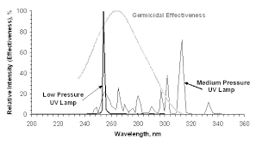

Figure 7-2.3.2 Germicidal effectiveness of UV lamps

The effectiveness of UV light on microorganism inactivation varies with different types of microorganisms. Generally, UV resistance by the microorganisms appears to follow microorganism size with the smallest microorganism being the most resistant. This is due to amount of UV light absorption per cell. Because viruses are the most resistant to UV disinfection dosing is controlled by log inactivation requirements of viruses.

The table below describes the UV dosage required to destroy the microorganism.

Table 2-2.3.2 UV Dosage requirements for microorganism's inactivation

|  |  |  |
| --- | --- | --- |
| **Micro organisms** | **Dosage of ultra-violet radiation (UV dose) in mW sec/cm2 needed to kill the selected microorganism.** | |
| **Bacteria** | **90%**  **(1 log reduction)** | **99%**  **(2 log reduction)** |
| Bacillus subtilis | 5.8 | 11 |
| Escherichia coli | 3 | 6.6 |
| Pseudomonas aeruginosa | 5.5 | 10.5 |
| Pseudomonas fluorescens | 3.5 | 6.6 |
| Salmonella enteritidis | 4 | 7.6 |
| Salmonella paratyphi-enteric fever | 3.2 | 6.1 |
| Salmonella typhosa-typhoid fever | 2.1 | 4.1 |
| Salmonella typhimurium | 8 | 15.2 |
| Sarcina lutea | 19.7 | 26.4 |
| Shigella dysenteriae-dysentery | 2.2 | 4.2 |
| Shigella flexneri-dysentery | 1.7 | 3.4 |
| Shigella paradysenteriae | 1.68 | 3.4 |
| Staphylococcus aerus | 2.6 | 6.6 |
| Vibrio comma- cholera | 3.4 | 6.5 |
| virus | 90% | 99% |
| Bacteriophage-E. coli | 2.6 | 6.6 |
| Infectious hepatitis | 5.8 | 8 |
| Poliovirus-poliomyelitis | 3.15 | 6.6 |

* + 1. LED Advantages

Recently with the development of semiconductor technology UV light emitting have emerged as new source to generate UV radiation. A LED is a semiconductor device that utilizes semiconductor materials p-type and n-type. The p for “positive” type contains excess holes while n type(negative) excess electrons. With a suitable voltage applied to a p-n junction electrons and holes recombine at the junction to emit radiation whose radiation depends on semiconductor materials. The most common lads are visible LEDs for lighting which are increasingly used because of higher efficiency and lower cost.

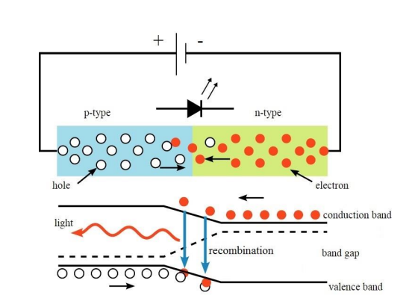

Figure 8-2.3.3 the circuit (top) and band diagram (bottom) on how an LED works

UV LEDs at various wavelengths can be manufactured using different semi-conductor materials. Mostly they are made using III-nitride, gallium nitride (GaN) and aluminum nitride (AIN) [11]. The wavelengths of UV-LEDs vary leading to its classifications. UVA range lies within 315-400nm, UV-C range is 200-280nm which is the shortest range among semiconductors [12].

The ability of UV-LEDs to offer a great variety of wavelengths is well aligned with need for efficient disinfection making it a potential option. UV LEDs can be designed to emit various wavelengths and offer the possibility to select a particular wavelength targeting a specific pathogen of concern. Since wavelengths of UV- LEDs can be customized polychromatic radiation can be easily achieved by the combination of UV-LEDs with the desired wavelengths. This provides an opportunity to construct the potentially optimal spectrum for more effective inactivation of target microorganisms.

UV-LEDs are semiconductor based enabling them to respond to electricity instantaneously. Pulsed radiation can be easily produced by connecting a pulse generator to the UV-LEDs and applying pulse voltage to turn on and off. Adjusting the duty cycle and different frequencies leads to improved inactivation as compared to continuous radiation [14].

* 1. Solar as a source of energy

Solar energy can be a major source of power. Solar is a renewable and efficient source that has no emissions. Its potential is 178 billion MW which is about 20,000 times the world’s demands. Sun energy can be utilized as either thermal or photovoltaics’. the energy radiated by the sun on a bright day us approximately 1kw/m2 which can be used in driving the prime movers for the purpose of generation of electrical energy. Applications where solar energy is used include solar water heater and solar cookers.

In this proposal solar energy is being collected using a solar panel and through the solar controller to charge the battery. The collected solar energy is being stored in the battery. In cases of rural and remote areas without access to electricity, this stored energy can be used to run the solar powered water purification system.

**CHAPTER THREE**

1. METHODOLOGY
   1. Design specifications of the proposed water purifier

The proposed solar based water purifier will have the following specifications

* Solar powered with a solar panel, charge controller and battery. This will provide the required electrical energy to power the ultra-violet LED.
* System will house an ultrafiltration filter with a pump to provide pressure for the filtration to take place on the filtration membrane.
* Use of ultra-violet LEDs in the ultra-violet chamber to provide for UV- disinfection enabling the purification of water for drinking purposes.
  1. Components of the Proposed Solar water purifier

Considering the necessary requirements, the chosen solution to build the water purifier system will be based on the following components

* Ultrafiltration filter
* Water pump
* Ultra-violet LED
* Relay
* Microcontroller
  + 1. Ultrafilter

This is the unit that will carry out the filtration process in order to filter out suspended particles in the water.

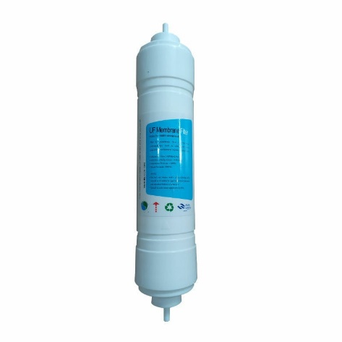

Figure 9-3.2.1 Ultrafiltration filter

* + 1. Water pump

This is a pump that provides the necessary pressure to force water across the ultrafilter membrane.

* + 1. UV-C LED

This is a semiconductor-based LED that produces radiation in the UV-C range when powered. The emitted radiation will be used to disinfect the water. The UV-LEDs are rated at 40mA, 12V and 3mW power output at wavelength of 270-285nm. It has a 1000hrs life span.

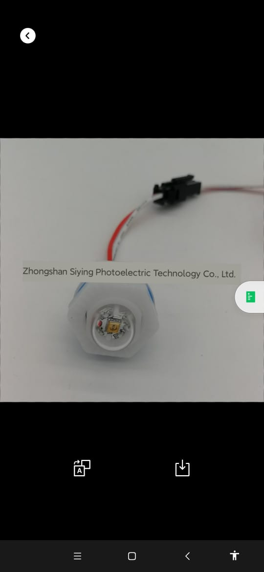

Figure 10-3.2.3 UV-C LED

The LEDs will be housed in the UV-C Chamber.

* 1. Design of UV-C chamber

The placement of UV-LEDs within the chamber depends on both how far the LED is from the radiation surface. As the LED moves away from the target, the intensity of the resulting UV-C light decreases.

The intensity of the UV-C power is inversely proportional to the distance between the LED and the target object.

UV dose = irradiance x time

For most UV LEDs they are rated at 5mm irradiation distance for 10 seconds to 60 mins

Validity of 1/r2 law is valid for all case that lateral dimension dx and dy of the spot light source are far much smaller than r:  dx << r and dy << r

In our case diameter or pipe is far much smaller than length of pipe

The further away the light source is the lesser the intensity

Conversion metric **1mW/cm2 = 10W/m2**

Since we are targeting e-coli we need radiation output of 6mWsec/cm2 = 6mW = 60W/m2

Our radiation from 3 UV-LEDs is 90W/m2 but we need to achieve 60W/m2 at a given radiation distance r (HOW MUCH DISTANCE THE UV-LIGHT TRAVELS)

Since r is quite large, we can approx. to 0.5m = 50cm so that light travels lesser distance so intensity increases.

Also remember 6mWsec -> 1 cm2 for E-coli

Assuming we use a steel pipe with radius 1.5cm

Total area of contact of UV radiation on the pipe = circumference of pipe x length (radiation distance)

But for the LED 6mW –> 1 sec –> 1cm2

So, for 470cm2 we will need

The total volume of water in this chamber =

The maximum flow rate to ensure that all the water in UV chamber with volume of 700cm3 will be

Any other flow rate Less than 4L/hour will increase time of exposure hence it can work, but not GREATER than 4L/Hour

* 1. Control Mechanism

For the control process we propose to use a SIM900L microcontroller. The microcontroller will control the switching of the pump as well as the powering of the UV-LED.

* + 1. Block diagram

We shall be using a 20W solar panel for getting electrical supply which is the fed to charge controller which charges the battery up to 12V. There’s a voltage regulator which is ensures there’s stability of input voltage in the circuit, the supply from the battery is fed to pump. The entire process will be controlled by the microcontroller. The relay acts a switch for opening and closing the circuit so that the water is purified only upon demand. The input water in the raw water tank is fed to the ultrafilter, using the pump, which removes particles. The water is then fed into the UV-C chamber which kill bacteria form in the water and we get purified water.

The block diagram for solar power water purification and filtration filter is given below in Fig 11-3.4.1.

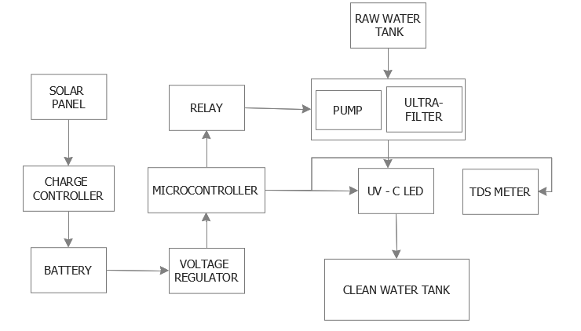

Figure 11-3.4.1 (a) Block diagram

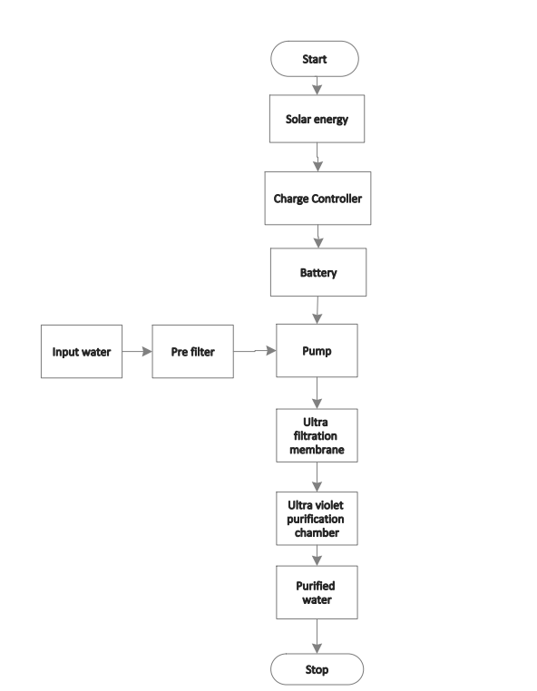The Fig 12-3.4.1 below shows flow chart of the whole system.

Figure 12-3.4.1 (b) Flow Chart

* 1. Microcontroller

T-call sim800L esp32 board is a microcontroller board with Bluetooth, Wi-Fi, SMS and connect to internet using data Plan on the sim card.

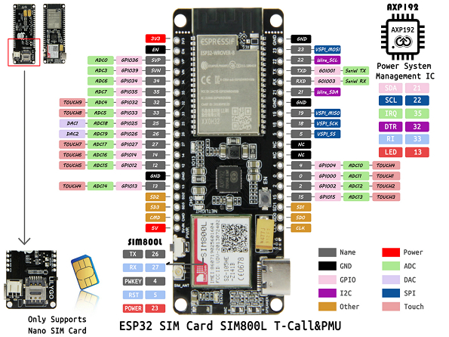

Figure 13-3.5 SIM800L Microcontroller

This microcontroller has an inbuilt Nano sim card connection and has a power requirement of 5V via USB-C or 3.3V via 3.3V pin. The microcontroller can be programmed via Arduino ide to control the purification process.

* 1. Water filtration and purification process

The process flow diagram for the purification process is given below in Fig.14-3.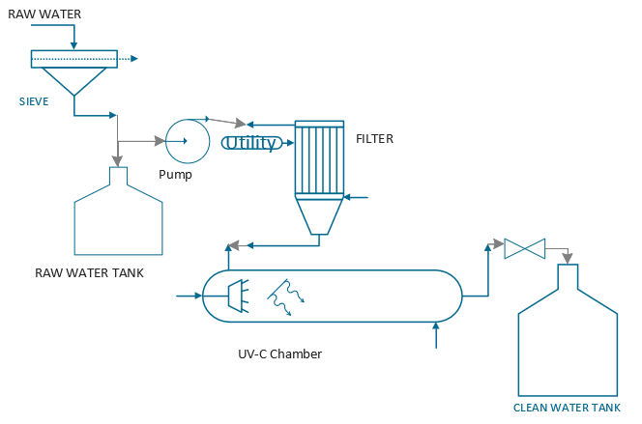6

Figure 3.4 Process Flow Diagram

Figure 14-3.6 Process Flow diagram

Figure 14-3.6 Process Flow diagram

People fetch water from a cloudy water source using 20 litre water containers. The water is then poured into the storage container of our device.

Once a user opens the valve (which acts as the tap), a switch is triggered. The Arduino then turns on the submersible pump which in turn pushes water through the ultrafiltration membrane. The water flows through a (a T –junction) pipe fitted with a UV LED for purification before it flows out the manual valve.

The dirty water undergoes three processes as shown in the table below;

Table 3-3.6 Water Treatment stages

|  |  |
| --- | --- |
| Pre-treatment | Sieve of 200 um which removes dirt, and solid particles |
| Main-treatment | Ultrafiltration membrane filter pore size 0.01 micron. Removes bacteria (E. Coli which can cause diarrhea, urinary tract infections, respiratory illness, pneumonia and other illnesses.), protozoa and some viruses |
| Post-treatment | Ultraviolet light from LEDs. This further eliminates bacteria, viruses and protozoa (like giardia lamblia cysts which cause stomach bloating, nausea and diarrhea) from the water. |

* + 1. System layout design

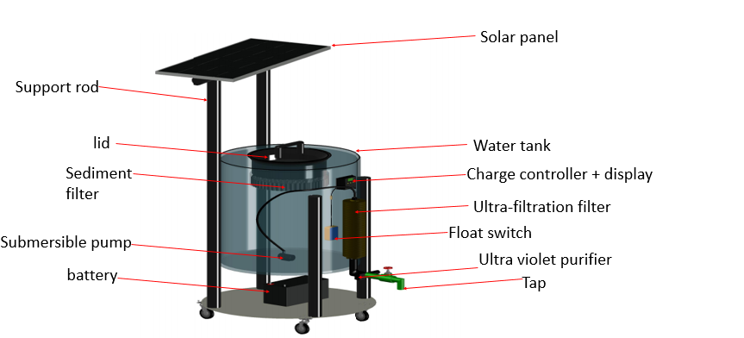

Figure 15- 3.6.1 Design layout

* 1. Energy consumption and Panel Sizing

SIM800L LILYGO WIFI GSM module – 5V/1A USB

Total current drawn by Arduino is 25mA at 6V.

Total current drawn by DC submersible pump is 1200mA at 12V.

Total current drawn by one ultra-violet LED . However, we are using three therefore; UV-c wavelength is 270nm-285nm.

Total load current is running for 6 hours. (6 hours is hours of sunlight Kenya gets per day)

Power of load is

Solar panel supply is 15W, which can be scaled up to 20 W at 12V for higher energy supply even on a cloudy day. Battery power

Ultra-filter membrane flow rate=4 liters per minute.

.

Maximum pressure = 120psi

Amount of time required to expose the cloudy water to UV-c rays is 3min in order to obtain a 3log10 reduction of coliform bacteria.

* + 1. Energy consumption

Electrical energy per order, EEO is a parameter for characterizing the electrical energy efficiency of disinfection systems. It is used for interpreting collimated beam data to estimate electrical efficiencies of low power UV and medium power UV lamps for biological inactivation EEO defines the amount of energy (kWh/m3) required to decrease the concentration of a contaminant or a microorganism by one order of magnitude.

A is the irradiated surface area in cm2, V is the sample volume in liters, KD is the log10 fluence based rate constant in cm2 /mJ, C is the wall plug efficiency given by the manufacturer, WF is the water factor, accounting for the UV absorbance and depth of the water. The factor 3.6×106 is to convert between hours and seconds, mW and kW and L and m3.

**CHAPTER FOUR**

1. EXPECTED RESULTS

A working prototype of the solar powered water filtration and purification system will be able to filter and purify dirty water and make it suitable for drinking. According to our design, the maximum amount of water purified per day should be 25.2 liters. The amount of purified water will depend on the usage of water by the user. Graph of amount of purified water over the days should be drawn. A solar powered UV LED purification unit will be constructed. A solar powered water filtration unit will be constructed.

**DIVISION OF ROLES**

|  |  |  |  |
| --- | --- | --- | --- |
| CHARLES KARIRA  ENE212-0267/2016 | | JOSEPHINE TARIYA  ENE212-0073/2016 | |
| Proposal | | | |
| 1. Literature review – UV disinfection 2. Circuit design 3. Design calculations of the UV chamber | | 1. Introduction 2. Literature review – Ultrafiltration 3. Microcontroller research and implementation | |
| Implementation | | | |
| Arduino code  PCB design | | Fabrication | |
|  |  | |  |

BUDGET

|  |  |  |  |  |
| --- | --- | --- | --- | --- |
| Item | Description | Quantity | Rate | Amount |
| 1 | Ultrafiltration filter | 1 | 2000 | 2000 |
| 2 | Raw water tank | 1 | 500 | 500 |
| 3 | Dc pump | 1 | 350 | 350 |
| 4 | Solar panel | 1 | 3000 | 3000 |
| 5 | Uv-c LED | 3 | 1200 | 3600 |
| 6 | Battery charger | 1 | 1000 | 1000 |
| 7 | battery | 1 | 3000 | 3000 |
| 8 | microcontroller | 1 | 1400 | 1400 |
| 9 | Manual valve | 1 | 700 | 700 |
| 10 | Sieve | 1 | 1300 | 1300 |
| 11 | Switch | 1 | 50 | 50 |
| 12 | Miscellaneous |  |  | 2100 |
| TOTAL | | | | 19000 |

**TIME-PLAN**

|  |  |  |  |  |  |  |  |  |
| --- | --- | --- | --- | --- | --- | --- | --- | --- |
| **ACTIVITIES** | **MAY** | **JUNE** | **JULY** | **AUG** | **SEP** | **OCT** | **NOV** | **DEC** |
| **Documentation** |  |  |  |  |  |  |  |  |
| **Proposal Writing** |  |  |  |  |  |  |  |  |
| **Literature Review** |  |  |  |  |  |  |  |  |
| **Proposal Presentation** |  |  |  |  |  |  |  |  |
| **Design and coding** |  |  |  |  |  |  |  |  |
| **Hardware** configuration**, testing and adjustment** |  |  |  |  |  |  |  |  |
| **Final Report writing** |  |  |  |  |  |  |  |  |
| **Final Presentation** |  |  |  |  |  |  |  |  |

REFERENCES

[1] Duff, W.S., Hodgson, D., 2002. A simple high efficiency solar water purification system. In: Proceedings of the 2002 Annual Conference of the American Solar Energy Society, 15–20, Reno, Nevada, American Solar Energy Society, Boulder, Colorado.

[2] W. S. Duff and D. Hodgson, “Solar Water Purification by Pasteurization,” *Solar Energy*, 2006.

[3] K. Song, M. Mohsen, and F. Taghipour, “Application of ultraviolet light-emitting diodes (UV-LEDs) for water disinfection: A review,” *Water Research*, vol. 94, pp. 341–349, 2016.

[4] Jarvis, Autin, Goslan, and Hassard, “Application of Ultraviolet Light-Emitting Diodes (UV-LED) to Full-Scale Drinking-Water Disinfection,” *Water*, vol. 11, no. 9, p. 1894, 2019.

[5] K. Song, F. Taghipour, and M. Mohseni, “Microorganisms inactivation by continuous and pulsed irradiation of ultraviolet light-emitting diodes (UV-LEDs),” *Chemical Engineering Journal*, vol. 343, pp. 362–370, 2018.

[6] Y. A. Pachepsky and D. R. Shelton, “Escherichia Coliand Fecal Coliforms in Freshwater and Estuarine Sediments,” *Critical Reviews in Environmental Science and Technology*, vol. 41, no. 12, pp. 1067–1110, 2011.

[7] W. A. M. Hijnen, E. F. Beerendonk, and G. J. Medema, “Inactivation credit of UV radiation for viruses, bacteria and protozoan (oo)cysts in water: A review,” *Water Research*, vol. 40, no. 1, pp. 3–22, 2006.

[8] A.-C. Chevremont, J.-L. Boudenne, B. Coulomb, and A.-M. Farnet, “Fate of carbamazepine and anthracene in soils watered with UV-LED treated wastewaters,” *Water Research*, vol. 47, no. 17, pp. 6574–6584, 2013.

[9] Autin, O., Romelot, C., Rust, L., Hart, J., Jarvis, P., MacAdam, J., Parsons, S.A. and Jefferson, B., 2013. Evaluation of a UV-light emitting diodes unit for the removal of micropollutants in water for low energy advanced oxidation processes. Chemosphere.

[10] O. Autin, C. Romelot, L. Rust, J. Hart, P. Jarvis, J. MacAdam, S. A. Parsons, and B. Jefferson, “Evaluation of a UV-light emitting diodes unit for the removal of micropollutants in water for low energy advanced oxidation processes,” *Chemosphere*, vol. 92, no. 6, pp. 745–751, 2013.

[11] M. Asif Khan, M. Shatalov, H. P. Maruska, H. M. Wang, and E. Kuokstis, “III–Nitride UV Devices,” *Japanese Journal of Applied Physics*, vol. 44, no. 10, pp. 7191–7206, 2005.

[12] Y. Taniyasu, M. Kasu, and T. Makimoto, “An aluminium nitride light-emitting diode with a wavelength of 210 nanometres,” *Nature*, vol. 441, no. 7091, pp. 325–328, 2006.

[13] M. A. Würtele, T. Kolbe, M. Lipsz, A. Külberg, M. Weyers, M. Kneissl, and M. Jekel, “Application of GaN-based ultraviolet-C light emitting diodes – UV LEDs – for water disinfection,” *Water Research*, vol. 45, no. 3, pp. 1481–1489, 2011.

[14] S. Wengraitis, P. McCubbin, M. M. Wade, T. D. Biggs, S. Hall, L. I. Williams, and A. W. Zulich, “Pulsed UV-C Disinfection of Escherichia coli With Light-Emitting Diodes, Emitted at Various Repetition Rates and Duty Cycles,” *Photochemistry and Photobiology*, vol. 89, no. 1, pp. 127–131, 2012.

[15] N. Hancock, “Ultrafiltration, Nanofiltration and Reverse Osmosis,” *Safe Drinking Water Foundation*, 15-Aug-2018. [Online]. Available: https://www.safewater.org/fact-sheets-1/2017/1/23/ultrafiltrationnanoandro. [Accessed: 13-Jul-2021].

[16] “Advantages and Disadvantages of Ultrafiltration,” *BIOTECH*, 30-Oct-2016. [Online]. Available: https://biotechwater.com/advantages-disadvantages-ultrafiltration/. [Accessed: 13-Jul-2021].

[17] L. Baker, Y. Choi, and C. Martin, “Nanopore Membranes for Biomaterials Synthesis, Biosensing and Bioseparations,” *Current Nanoscience*, vol. 2, no. 3, pp. 243–255, 2006.

[18] A. W. Mohammad, N. Hilal, H. Al-Zoubib, N. A. Darwish, and N. Ali, “Modelling the effects of nanofiltration membrane properties on system cost assessment for desalination applications,” *Desalination*, vol. 206, no. 1-3, pp. 215–225, 2007.

[19] “Microfiltration,” *Membrane Technology and Applications*, pp. 303–324, 2012.

[20] M. C. Tombs, “John C. Crittenden, R. Rhodes Trussell, David W. Hand, Kerry J. Howe, George Tchobanoglous: MWH Water Treatment Principles and Design. Third Edition,” *Chromatographia*, vol. 77, no. 5-6, pp. 527–528, 2013.

[21] “Advantages and Disadvantages of Reverse Osmosis,” *BIOTECH*, 30-Oct-2016. [Online]. Available: https://biotechwater.com/advantages-disadvantages-reverse-osmosis/. [Accessed: 13-Jul-2021].

[27] “Solar Drinking Water Disinfection (SODIS) to Reduce Childhood Diarrhea,” *Recent Advances and Issues in Environmental Science*, pp. 205–225, 2011.

[28] V. Meera and M. M. Ahammed, “Solar disinfection for household treatment of roof-harvested rainwater,” *Water Supply*, vol. 8, no. 2, pp. 153–160, 2008.

[29] “Water, sanitation and hygiene,” *UNICEF Kenya*. [Online]. Available: https://www.unicef.org/kenya/water-sanitation-and-hygiene. [Accessed: 02-Aug-2021].